**Pozyx Setup Notes – Single Tag**

## Step 1: Place 4x Anchors in desired locations

* NOTE: 4x Anchors are required for 3-D positioning
* Position / locate Anchors in a space to define a cubic volume
* Set Anchor heights (‘z’ position) alternating high / low (odiagonally opposite)

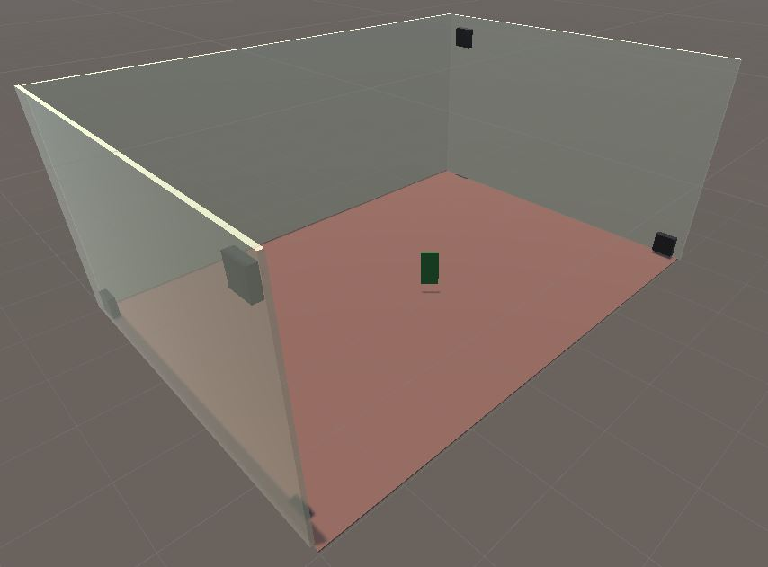

Tag

Anchors

Anchors

* One Anchor must be connected to your computer / laptop via USB cable. For ease of use, this Anchor can be defined as the point of origin
  + Point of origin anchor has position (0, 0, z)
    - ‘z’ value is set to height of anchor (height is always measured from ground / floor)
* Measure / record each remaining anchor’s position (x, y, z) relative to the point of origin
  + NOTES:
    - ‘x, y’ values are set relative to point of origin
    - ‘z’ value is set to height of anchor (height is always measured from ground / floor)
    - Take measurement from Centre-Top of Anchor
      * where UWB chip is located on board
    - Assign coordinate axes using right hand grip rule
    - Some positions can be negative
* Connect remaining 3x Anchors (remotes) to power outlets and switch on

## Step 2: Required Downloads / Installations

* (Optional) Install Unity3d (2018.2.18f1 or later)
  + <https://unity3d.com/>
* Install ST’s virtual COM driver:
  + Google Drive link:
    - <https://drive.google.com/file/d/1f2j_OHPpYvawyQaeYCNG52dGGsCwoMNI/view?usp=sharing>
  + NOTE: This driver is required, even for Windows 10.
* Download the Pozyx Single-Tag Positioning Application:
  + Google Drive link:
    - <https://drive.google.com/file/d/1rpPslMHY0bWWWzUqmdbuixaF3MZqA5pb/view?usp=sharing>
  + NOTE: this application is used for a (single) Pozyx tag positioning / orientation
  + NOTE: this application may be used for either:
    - Single Tag positioning / orientation
    - Multiple Tag positioning / orientation
  + See Step 4 (below) for additional information

## Step 3: Pozyx Tag(s)

* Connect one (or more) Pozyx Tags to a power source (ie. 9-volt Battery or USB-port / electrical outlet)
* OPTIONS:
  + 9v to 2.1mm DC plug cable (Figure 3a)
    - NOTE: 2.1mm to 2.5mm DC plug adapter required
  + 9v to micro USB (phone charger unit) (Figure 3b)

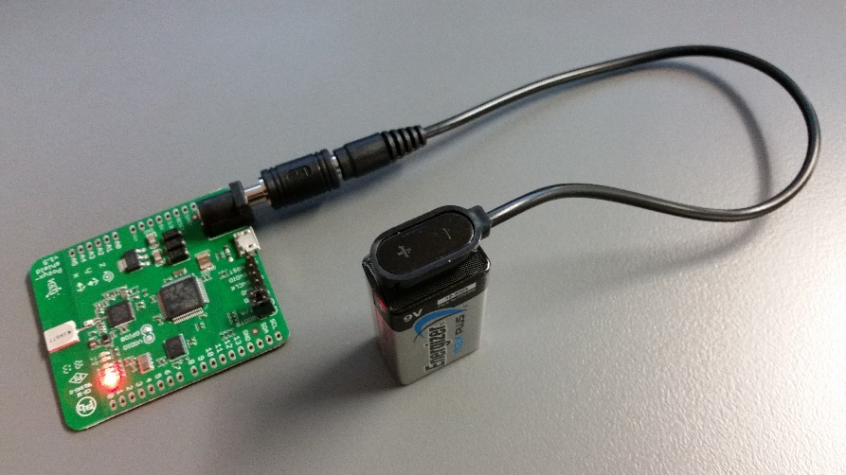

Figure 3a: Pozyx Tag connected to 9v battery via DC plug cable and adapter

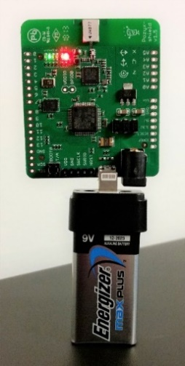

Figure 3b: Pozyx Tag connected to micro USB (phone charger unit)

## Step 4: Run Pozyx – Single Tag Positioning Application (Python-based)

* Download pozyxSingleTag.zip and unzip contents to a user-designated folder on PC
  + Google Drive link:
    - <https://drive.google.com/file/d/1rpPslMHY0bWWWzUqmdbuixaF3MZqA5pb/view?usp=sharing>
    - Ignore any warnings
  + Contents of file:
    - pozyxSingleTag.exe - application to run Pozyx (single) tag positioning
    - tagIDs.txt - list of available tags (Do not modify)
    - anchors.txt - list of anchor IDs and user-defined co-ordinates
* Open ‘anchors.txt’ file in Notepad or any text file editor
  + Edit / update anchor (x, y, z) co-ordinates for each anchor (as required)
    - Using measured values from Step 1
    - NOTE: this file only needs to be modified / updated if the Pozyx Anchors’ positions are changed

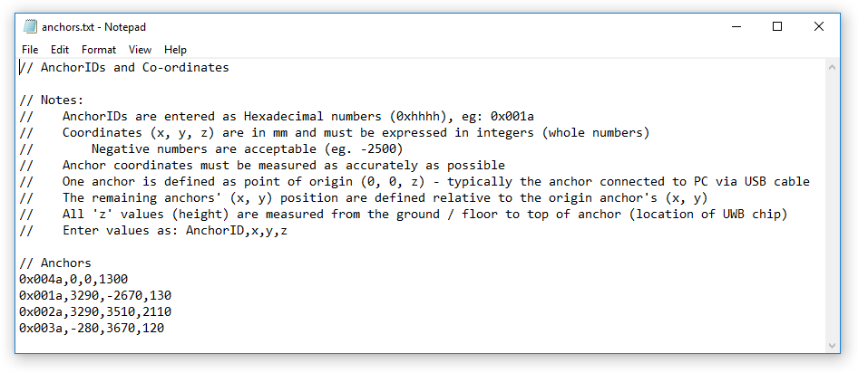

Figure 4: Contents of ‘anchors.txt’ file showing anchor IDs and user-definable coordinates

* Run pozyxSingleTag.exe application file (double-click)
  + NOTES:
    - ensure Pozyx Anchors and Tag are connected and powered up prior
    - for first time execution, ignore any Windows security warnings

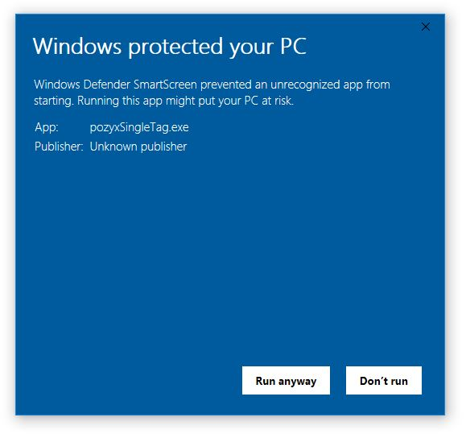

Figure 5: Ignore Windows Defender warnings: click ‘Run anyway’

* + - ‘tagIDs.txt’ and ‘anchors.txt’ files must be kept in same directory as pozyxSingleTag.exe
  + application will execute and a console window will be displayed, showing a user menu

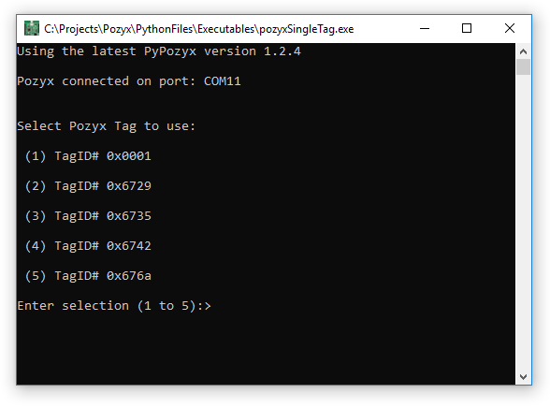

Figure 6: Pozyx Tag selection menu is presented to user

* + select the appropriate Pozyx Tag from the menu
    - eg: 1 to operate Pozyx Tag #0x0001
  + Pozyx Tag will commence positioning

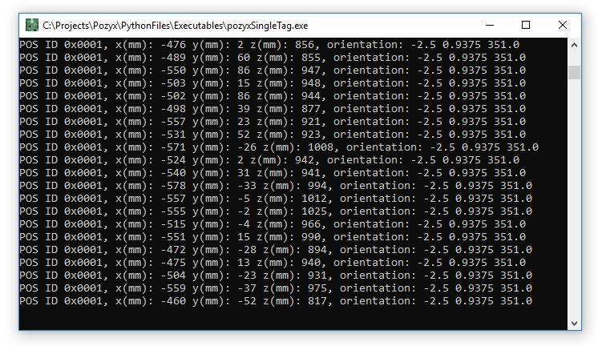

Figure 7: Sample output of Pozyx positioning system during execution

* + NOTES:
    - this application feeds position (x, y, z) and orientation (p, r, y) into Unity via OSC Protocol
    - this application MUST be run prior to attempting to run the Unity Project
    - anchor co-ordinates (x, y, z) are stored in ‘anchors.txt’ file and should be modified only if anchor(s) are moved into a new location / position (Figure 4)
    - tag IDs (hexadecimal values) are stored in ‘tagIDs.txt’ file and should not be modified
      * corresponding tag ID labels are stuck on to rear of tags (Figure 8)

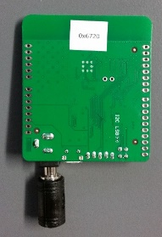

Figure 8: Pozyx Tag ID

## Step 6: (Optional) Run Unity-Project: PozyxUnity - SingleTag

* Download and unzip the Unity project ‘PozyxUnity – SingleTag’ to a user-designated folder:
  + Google Drive link:
    - <https://drive.google.com/file/d/1RP4hsVZryN91K9Id88VVdQQ0z3N2tTY9/view?usp=sharing>
    - Ignore any warnings
* Open Unity project ‘PozyxUnity – SingleTag’ in Unity3D application
  + (Optional) Select ‘Pozyx Tag’ game object (left menu) and enter desired position and orientation smoothing values (right menu: Position (Script))
    - NOTES:
      * Smoothing values can be individually set for both position and / or orientation motion to reduce jerkiness
      * Values are set from:
        + 1 = No smoothing
        + 2 or greater = increased smoothing
      * Higher smoothing values increases motion latency / delay

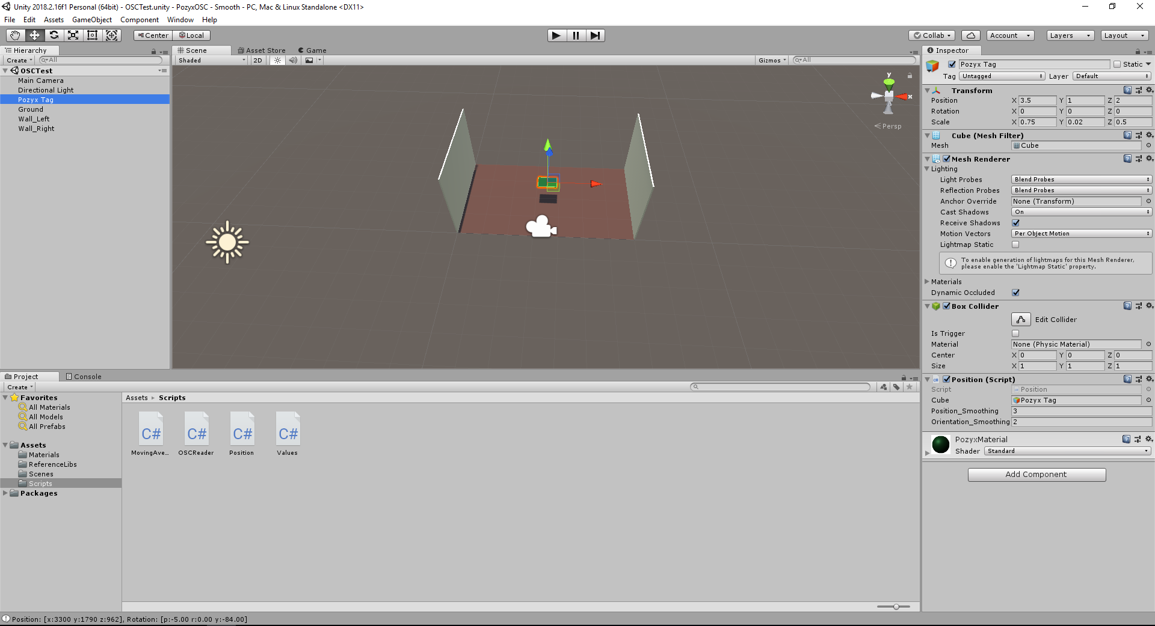

Figure 9: Unity project interface

* While ‘pozyxSingleTag.exe’ is running (see Step 5), press ‘PLAY’ on Unity interface
  + NOTES:
    - ‘pozyxSingleTag.exe’ must be running prior to playing the Unity project
      * Data is fed from Pozyx, into the application and then streamed into Unity via Open Sound Control (OSC) protocol
    - STOP playing Unity project **before** stopping / closing Python script
      * To avoid a continuous loop / Unity appears to hang
      * If this does occur, simply re-run python script

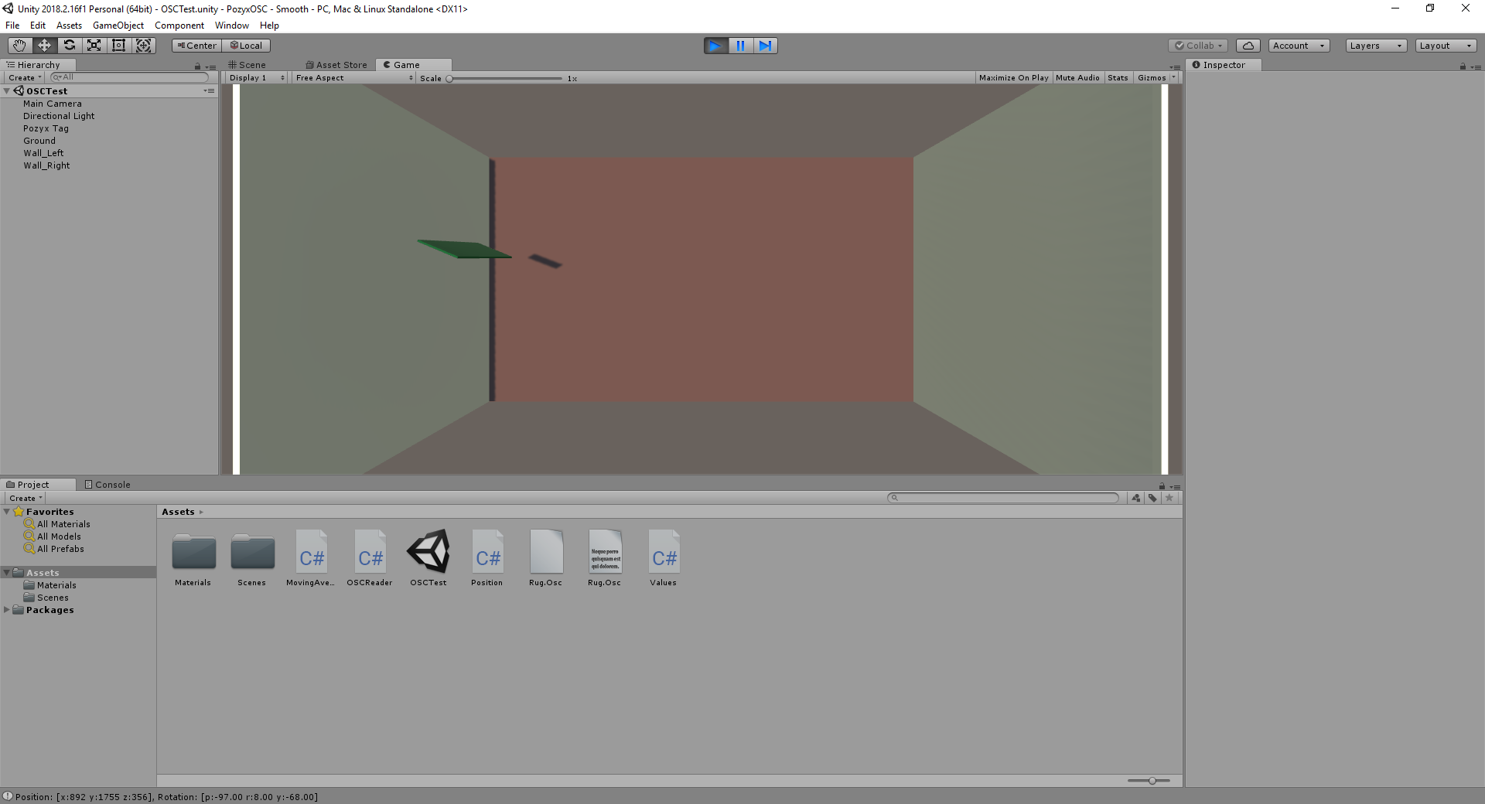

Figure 10: Running ‘PozyxUnity – SingleTag’ Unity Project

## Additional Notes

* Accuracy of the Poxyx Tag(s) may diminish as battery life deteriorates

## Source Code

* All source code (Python) files are available on Google Drive:
  + Link: https://drive.google.com/drive/folders/1fSZsK0Kfqo2mBGzqIN_doj5CTJE9IFVQ?usp=sharing
* Original Pozyx source code (Python) files are available on Google Drive:
  + Link: <https://drive.google.com/drive/folders/140HnsQ3DgbZL-wxljcpPInDfQ488XVY4?usp=sharing>
  + Github: <https://github.com/pozyxLabs/Pozyx-Python-library>
* Install Python 3.7 (or later)
  + <https://www.python.org/downloads/windows/>
  + Install 32-bit or 64-bit (as required)
  + NOTES:
    - make sure “Add Python 3.X to PATH” is checked / activated

(refer to Figure 1)

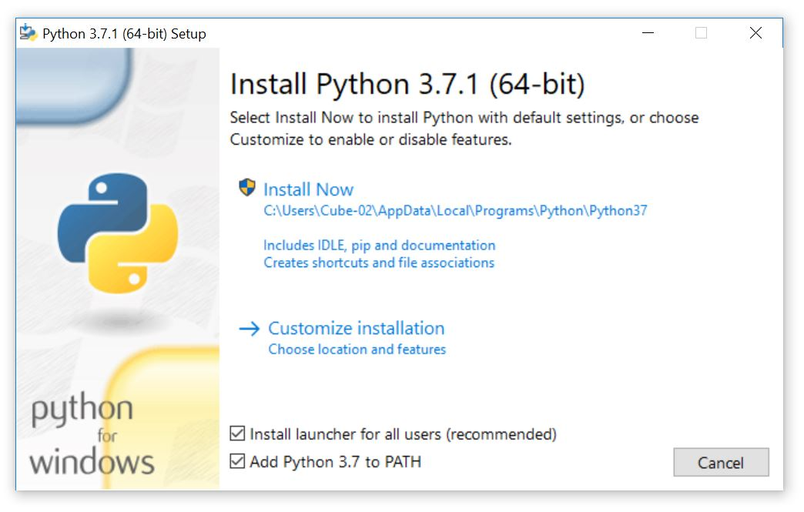

Figure 1: Add Python to PATH

* + - (optional) Disable PATH length limit

(refer to image)

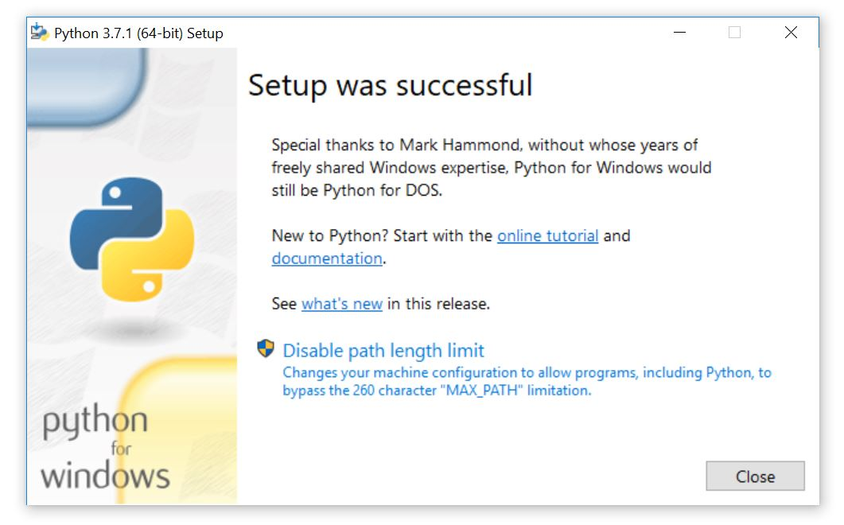

Figure 2: Disable Path length limit (optional)

* Install Pozyx and OSC Python libraries:
  + Download pozyxInstallPackages.zip, unzip and run pozyxInstallPackages.exe
    - Ignore any virus warnings
  + Google Drive link:

<https://drive.google.com/open?id=1DJPwCxmspRbBYAJbxxrxKIAEUOH08UbV>

* + NOTE: if there are problems downloading / installing packages using application, individual libraries can also be installed manually:
    - Open a “COMMAND-PROMPT” (DOS prompt) in Windows:
      * Press ‘Windows’ + ‘R’ keys
      * Enter cmd in RUN dialog
      * Press ENTER or click OK
    - At C:\> prompt, enter the following commands (individually):
    - pip install pypozyx
    - pip install python-osc
    - pip install requests
    - pip install pyserial
  + For additional information on Pozyx and application development: refer to <https://www.pozyx.io/Documentation/Tutorials/getting_started/Python>